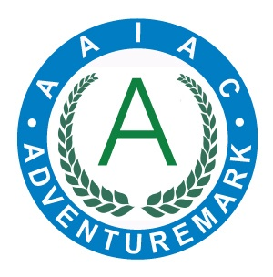
ADVENTUREMARK
www.adventuremark.co.uk
BF ADVENTURE
Has met the necessary standards for the safe delivery of
adventure activities as defined by the
Adventure Activities Industry Advisory Committee.

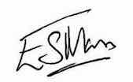
Elspeth Mason, Chair (AAIAC)

Abseiling | Orienteering
Archery | Rock Climbing
Artificial Climbing Wall | Sit on Top Kayaking
Bushcraft | Stand Up Paddle Boarding
Canoeing | Swimming – pool, sea, natural waters
Coasteering | Swimming pools in hotels,  hostels or campsites
Forest Schools
High Ropes Courses | Team Building
Improvised Rafting | Via Ferrata
Kayaking | Weaselling
Low Ropes Courses | Zip Wires

Date Issued : 30th March 2024 Expiry Date : 30th March 2026

Certificate No : AAA101412

